* ***Binary Search***

*Source Code:-*

#include <stdio.h>

#include <time.h>

int main()

{ clock_t start, end;

double time_used;

int i, low, high, mid, n, key;

start = clock();

printf("Enter number of elements\n");

scanf("%d",&n);

int array[n];

printf("Enter %d integers\n", n);

for(i = 0; i < n; i++)

scanf("%d",&array[i]);

printf("Enter value to find\n");

scanf("%d", &key);

low = 0;

high = n - 1;

mid = (low+high)/2;

while (low <= high) {

if(array[mid] < key)

low = mid + 1;

else if (array[mid] == key) {

printf("%d found at location %d.\n", key, mid+1);

break;

}

else

high = mid - 1;

mid = (low + high)/2;

}

if(low > high)

printf("Not found! %d isn't present in the list.\n", key);

end = clock();

time_used = ((double) (end - start)) / CLOCKS_PER_SEC;

printf("\n %f",time_used);}

Output:-

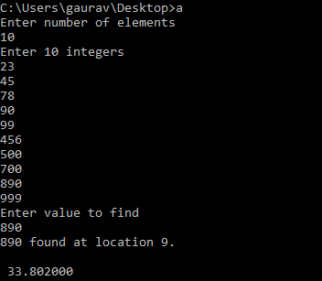

* ***LinearSearch***

Source Code:-

#include<stdio.h>

#include <time.h>

int main()

{ clock_t start, end;

double time_used;

int i,x,n;

start = clock();

printf("Number of Total Elements:");

scanf("%d",&n);

int a[n];

printf("Enter array elements:\n");

for(i=0;i<n;++i)

scanf("%d",&a[i]);

printf("\n Enter element to search:");

scanf("%d",&x);

for(i=0;i<n;++i)

if(a[i]==x)

break;

if(i<n)

printf("Element found at index %d",i);

else

printf("Element not found");

end = clock();

time_used = ((double) (end - start)) / CLOCKS_PER_SEC;

printf("\n %f",time_used);}

Output:-

